**20.Prime or not (input from the user)**

**Exercise**

* **Print if a number is prime or not (Input n from the user). (without creating a method or recursion using if else and for loop or do while loop only)**

**Approach:**

**So here we did like this**

**Java: (ctrl + “+” to zoom the page )**

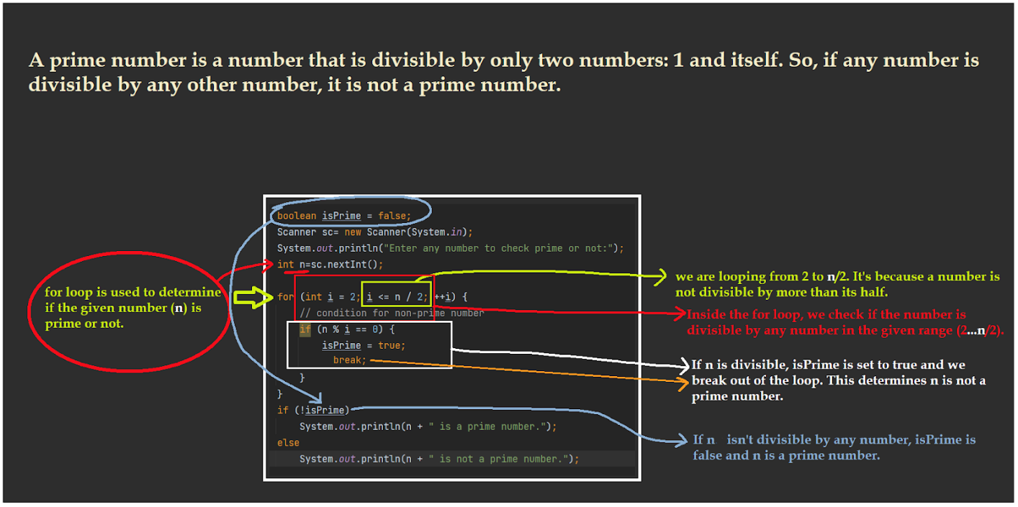

**Note : To find if a number is prime, why is checking till n/2 ?**

**Well, whenever you find a number which is Prime or not , you check it till n/2. That is true, and there is no problem checking it till n. But we don’t check it because there is no possibility of getting a number x which is divisible by n and which lies on the second half of the number (n/2).**

**Let’s check what I am talking about.**

**Consider the number 17. Check whether it is prime or not.**

**17%2≠0 (%=Modulus or Remainder)**

**17%3≠0**

**17%4≠0**

**17%5≠0**

**17%6≠0**

**17%7≠0**

**17%8≠0**

**17%9≠0 (Consider this which lies on the second half in the n/2).**

**You won’t find any more numbers which can produce the result.**

**The minimum number that can be divided by 17 is 2, and if you divide 17/9 which can’t give you the number which is less than 2. (We don’t consider 1 as minimum since 1 is divisible with every other number).**

**So, it is a waste of time to check further for any other number, or it is an inefficient algorithm in terms of computer programming.**

**Python :**

**1st approach = Just same as Java approach mentioned above**

**2nd Approach = In python we can simply use pip(package manager)  to install a python package which is called “sympy” , just go to your terminal(for windows CMD or Powershell or Windows Terminal for Win 11, system terminal for MaxOS and any Linux Based OS) and type “pip install sympy”, it will automatically download and install sympy. After that, type “from sympy import *” on your IDE (see the 1st line of the python solution mentioned below). Then we can use the isprime() method which we imported from sympy !**

**P.S. To uninstall any kinda pip package just type “pip uninstall *package_name*”**

**Solution 👇**

**Java :**

**import java.util.Scanner;**

**class CodeXam {**

**public static void main(String[] args) {**

**boolean isPrime = false;**

**Scanner sc = new Scanner(System.in);**

**System.out.println("Enter any number to check prime or not:");**

**int n = sc.nextInt();**

**if (n == 1 || n ==0) {**

**System.out.println(n + " is not prime number");**

**} else {**

**for (int i = 2; i <= n / 2; ++i) {**

**// condition for non-prime number**

**if (n % i == 0) {**

**isPrime = true;**

**break;**

**}**

**}**

**if (!isPrime)**

**System.out.println(n + " is a prime number.");**

**else**

**System.out.println(n + " is not a prime number.");**

**}**

**}**

**}**

**output:**

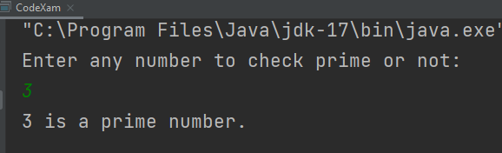

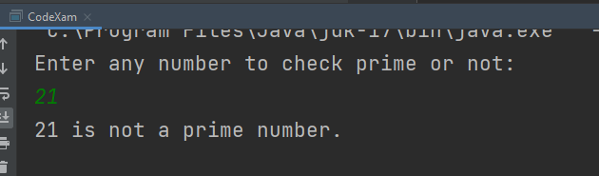

**Python :**

**num = int(input("Enter Your Number :\n"))**

**if num > 1:**

**for i in range(2, int(num / 2) + 1):**

**if (num % i) == 0:**

**print(num, "is not a prime number")**

**break**

**else:**

**print(num, "is a prime number")**

**else:**

**print(num, "is not a prime number")**

**#2nd approach**

**from sympy import \***

**x = int(input("Enter a number to check whether it's a Prime number or not:\n"))**

**if isprime(x):**

**print(x, "is a prime number indeed")**

**else:**

**print(x, "is not a prime number")**

**output:**

